**Web-based Ordering & Ingredient Estimating for Bakery Manufacturer**

Project Proposal

By

**Miss. Nontra Mahachanont 542115026**

**Mr. Parinya Panyanak 542115034**

Department of Software Engineering

College of Arts, Media and Technology

Chiang Mai University

Project Advisor

________________________

**Mr.Phudinan Singkhamfu**

**Document History**

|  |  |  |  |  |  |  |
| --- | --- | --- | --- | --- | --- | --- |
| **Document Name** | **Version** | **Status** | **Date** | **Viewable** | **Reviewer** | **Responsible** |
| **Documents** | | | | | | |
| Web-based Ordering & Ingredient Estimating for Bakery Manufacturer Proposal V.0.1.docx | V.0.1  - Add Abstract  - Add Chapter1  - Introduction & Background  - Adjust Project Name | Draft | 07-02-2014 | NM, PP, PS | NM, PP | NM, PP |
| Web-based Ordering & Ingredient Estimating for Bakery Manufacturer Proposal V.0.2.docx | V.0.4  - Add Chapter2  - Business Review  - Business Tools  - Software review  - Technology Review | Draft | 14-02-2014 | NM, PP, PS | NM, PP | NM, PP |
| Web-based Ordering & Ingredient Estimating for Bakery Manufacturer Proposal V.0.5.docx | V.0.5  - Add Development Tool Review  - Adjust Abstract  - Add Chapter3  - Quality Standards | Draft | 17-02-2014 | NM, PP, PS | NM, PP | NM, PP |
| Web-based Ordering & Ingredient Estimating for Bakery Manufacturer Proposal V.0.7.docx | V.0.7  - Add Chapter4  - Project Plan  - Adjust Technology Review  - Adjust Schedule & Milestone  - Adjust Project Name | Draft | 18-02-2014 | NM, PP, PS | NM, PP | NM, PP |
| Web-based Ordering & Ingredient Estimating for Bakery Manufacturer Proposal V.0.8.docx | V.0.8  - Add Chapter5  - References  - Adjust Chapter 1  - Adjust Chapter 2  - Adjust Chapter 4  - Adjust Project Name  - Fix inappropriate word | Draft | 03-03-2014 | NM, PP, PS | NM, PP | NM, PP |
| Web-based Ordering & Ingredient Estimating for Bakery Manufacturer Proposal V.0.9.docx | V.0.9  - Adjust Feature  - Adjust Project Name  - Adjust System architecture  - Fix inappropriate word | Draft | 21-03-2014 | NM, PP, PS | NM, PP | NM, PP |
| Web-based Ordering & Ingredient Estimating for Bakery Manufacturer Proposal V.1.0.docx | V.1.0  - Adjust Feature  - Adjust System architecture  - Adjust limits  - Fix inappropriate word | Released | 25-03-2014 | NM, PP, PS | NM, PP | NM, PP |
| Web-based Ordering & Ingredient Estimating for Bakery Manufacturer Proposal V.1.1.docx | V.1.1  - Adjust Project name  - Adjust Introduction &  Background  - Adjust Feature  - Fix inappropriate word | Draft | 18-04-2014 | NM, PP, PS | NM, PP | NM, PP |

|  |  |  |  |  |  |  |
| --- | --- | --- | --- | --- | --- | --- |
| Web-based Ordering & Ingredient Estimating for Bakery Manufacturer Proposal V.1.4.docx | V.1.4  - Adjust Chapter 1  - Adjust Chapter 2  - Adjust Chapter 4  - Fix inappropriate word | Released | 23-04-2014 | NM, PP, PS | NM, PP | NM, PP |

**\*NM = Nontra Mahachanont**

**\*PP = Parinya Panyanak**

**\* PS = Phudinan Singkhamfu**

**Table of contents**

**Chapter One | Introduction and Background** 5

**Chapter Two |Literature Review** 6

2.1 Business Review 6

2.2 Business Tools and Software Review 7

2.2.1Absolute |Solutions| Website 7

2.2.2Bakery land website 8

2.2.3PRIMS Software 9

2.3 Technology Review 10

2.3.1Spring Framework 10

2.3.2Cascading Style Sheets (CSS) 11

2.3.3HTML5 12

2.4 Development Tool Review 13

2.4.1NetBeans 13

2.4.2MySQL Workbench 14

2.4.3Adobe Dreamweaver 15

**Chapter Three | Quality Assurance** 16

3.1 ISO29110 for Very Small Entity (VSE) 16

3.1.1 Project Management Process 16

3.1.2 Software Implementation Process 16

**Chapter Four | Project Plan** 17

4.1 Motivation 17

4.2 Aims 17

4.3 Objectives 17

4.4 System Architecture 18

4.5 Deliverables and Limits 21

4.5.1 Deliverables 21

4.5.2 Limits 23

4.6 Future work 23

4.7 Schedule & Milestones 24

**Chapter Five |** Reference 30

**Chapter One | Introduction and Background**

Formerly, there are many problems in bakery manufacturer. From the Phungnoi bakery workflows, they allow wholesalers make an order of bakery products via e-mail, and the most of them use excel form to list their bakery’s orders. After that, the manufacturer has many officers to receive all orders via e-mail and convert information into manufacturer form individually. Then the manufacturer will distribute new document to the manufacturing part, preparing part, etc. The most common issues of Phungnoi bakery manufacturer are mistake ordering information, complication to manage the various orders, amount of ingredient usage each time and the clarity of documents. All of these problems are affecting to the original system of the manufacturer. The workers often use wrong document to cooperation with other colleagues. When the fact occurs, solution is workers will re-check all orders again and finding a new bakery product to replace the loss products. As a result, both wholesaler and worker are wasted more time and budget to resolving the problems.

Nowadays, there are many technologies and tools developed for solving the problems such as order management system and document management system. However, there are some gaps of the existing system. For example, they cannot apply ingredient management system to received orders from order management system to estimation. So the manufacturers that have problems may use these technologies to solve it. The technology that very useful and accuracy obtain orders from wholesalers to estimating ingredient's usage in manufacturing and report all information correctly and accurately. When the system shares the documents to another worker, they may understand it instantly and can work exactly. But there is one important problem that happens in manufacturing part. The problem is the manufacturer found that ingredients usage is inappropriate when comparing with the actual number of ordering information. The manufacture does not know that how many real ingredients are uses in each time because of past the statistics of ingredient usage are unstable. So the estimation ingredients will affect to the manufacturing part.

With these problems, our group decides to create Web-based Ordering & Ingredients Estimating for Bakery Manufacturer to solve all previous problems. By creating as a web application with consists with order management system, ingredient management system and summary report system. The main objective of this system is to handle the ordering information, control the manufacturing part for estimate the ingredients of the manufacturer and review into the reports. We hopefully that this system and all function implemented will solve the manufacturer management problem.

# **Chapter Two |Literature Review**

## Business Review

**Overview**

Web-based Ordering & Ingredient Estimating for Bakery Manufacturer is a web application that derived by JSP, HTML5, and CSS3. This system can be used for helping the manufacturer managing bakery orders and estimating how much to manufacturing a bakery product or how much ingredient needs to used in each manufacturing time. Then, it can report all information to be a graph. On the other hand, the system also helps the wholesaler make orders and manage their ordering information easily.

**Target**

The main target of Web-based Ordering & Ingredient Estimating for Bakery Manufacturer is to collect the orders from the wholesalers to facilitate cooperation in manufacturer and also estimating how much ingredient needs to use in each manufacturing from ordering information and the output can be reports.

**Benefit**

* Wholesaler gets convenient to order the bakery product.
* Wholesaler has a choice to manage their bakery order instantly.
* Wholesaler can know their ordered history.
* Admin can know how many bakeries should be manufacturing.
* Admin can know wholesale’s ordered history.
* Admin can know manufacturer’s manufacturing history.
* Manufacturer can control the usage of ingredients in the manufacturing part.
* Manufacturer can control the standard of bakery product.
* Manufacturer has accuracy bakery product for each wholesaler.

## Business Tools and Software Review

## Absolute |Solutions| Website

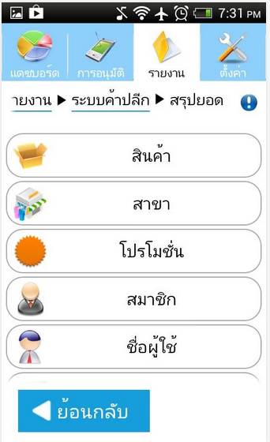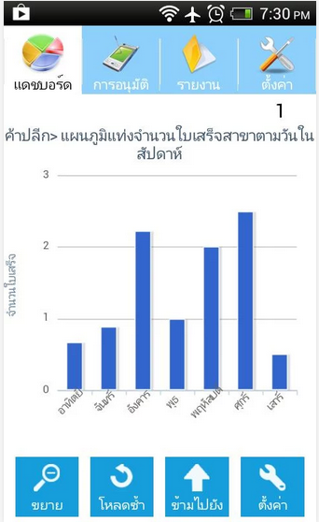

**Figure 1 Absolute |Solutions| Review** [7]

## Software Description

Figure 1: This application is a business management application that using technology cloud computing that provides server, database, and IT expert. The aims are to improve the company to better management. By use the wholesale and retail system, store system and order system [7].

## Pros

* All data is security from virus on machine.
* The user can save investment.
* Support using this web site with every operation system.
* Support alert message with SMS and email.

## Cons

* Support only officer can use a website.
* No estimate the ingredients from ordering information.
* No provides summary reports for users to keep as a record.

## Bakery land website

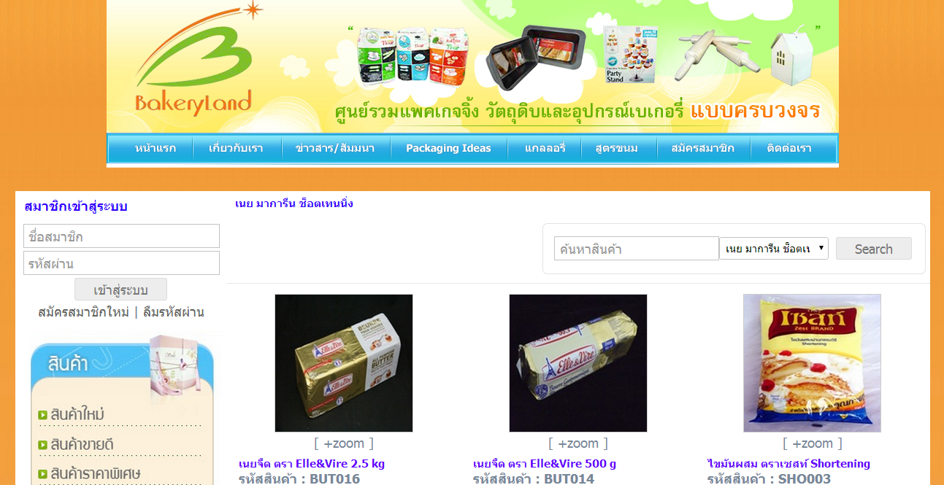

**Figure 2 Bakery land website Review** [8]

## Software Description

Figure 2: This website is the bakery online website using for trading bakery product. It has many types of product included package and bakery material. The aims are to improve the company to better marketing. By use the internet to sell the product [8].

## Pros

* The user can order the product through the website.
* Have tutorial description for ordering.
* Good category management.

## Cons

* Support only internet access areas.
* No covers all services for manufacturer side.
* Only customer can use the website.

## PRIMS Software

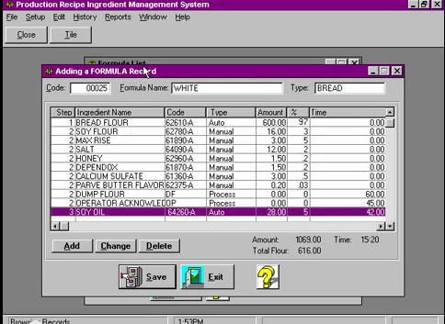

**Figure 3 PRIMS software Review** [9]

## Software Description

Figure 3: This program is the ingredient management program in the enterprise. It has many features to support such as scheduling, insures recipe compliance, eliminates operator errors, eliminates waste and records actual inventory usage [9].

## Pros

* Easy to use for no user experience to operation.
* Flexible technology to control over manual operation.
* Record each step in the process.
* Fast and accuracy.

## Cons

* No automated receive ordering information to calculate.
* No online interactive.
* No covers all report type function for users.

## Technology Review

## Spring Framework



**Figure 4 Spring Framework Logo** [12]

## Technology Detail

Figure 4: The spring framework is an open source tool for supporting Java-based enterprise application development. This framework use to develop any java application and make J2EE easy to use. It contains pattern and configuration for programming that can be deployed on any platform. It also supports various components to work together such as JDBC and Hibernate [11].

## Alternative Technology

* ASP.NET Framework

## The selection of this technology

* Support MVC pattern.
* Support .Net and java.
* Easy for unit testing when split it to another part with JUnit.
* Support to connect with various components and technologies.

## Cascading Style Sheets 3 (CSS3)



**Figure 5 CSS3 Logo** [14]

## Technology Detail

Figure 5: CSS is stands for Cascading Style Sheets. It is the last version of CSS style sheets used to design element of the website such as layout, color, size or font of the website. Then display HTML elements that presentation of web pages [13].

## The selection of this technology

- CSS makes web pages look better than only HTML does.

- Helps to design the web flexibility.

- Redesign (i.e. colors, size, fonts) with not has effect to HTML code.

- A feature more than the old version such as Combinatory, CSS Selectors, Pseudo-elements, Style properties.

## HTML5



**Figure 6 HTML5 Logo** [6]

## Technology Detail

Figure 6: HTML5 is the lasts revision of the HTML. It is a markup language to create a user interface for present contents that can be displayed in a web browser [6].

## Alternative Technology

* Another HTML version
* XHTML

## The selection of this technology

- Makes creating accessible sites easier.

**-** Allow other can access easily.

**-** Simple and clean.

**-** Easy to handle error.

**-** Reduce the external plug-in such as flash.

**-** Support for local storage.

**-** New content-specific elements, like <article>, <footer> and <header>.

**-** New form controls, like calendar, date, time, email and URL.

## Development Tool Review

## NetBeans



**Figure 8 NetBeans Logo** [9]

## Development Tool Description

Figure 8: NetBeans is an open-source program to integrated development environment for developing with any language such as Java, PHP, C++ and other programming language. It is referred to developing Java desktop applications and also develops web application. It's constantly improving Java Editor, provide many features and an extensive range of tools, templates and samples [10].

## Alternative Tool

* Eclipse
* IntelliJ IDEA

## The selection of this tool

* Open source for any users no need license or contract.
* Provide many features necessary for MVC pattern development.
  + Support Ant and Maven – no custom built system that only works in the IDE.
  + Includes new features for editing/debugging HTML5.
  + Written using swing.
  + Built-in support for version control systems plug-ins. For example, it can be a nightmare to get SVN configured correctly on 64 bit systems.

## MySQL Workbench



**Figure 9 MySQL Workbench Logo** [16]

## Development Tool Description

Figure 9: MySQL Workbench is an open source relational database management system which used for develop database architects. It can do such as provides data modeling, comprehensive administration tools for server configuration, SQL development, user administration and backup. Then also supports many development tool for create a web application such as Eclipse and NetBeans [15].

## Alternative Tool

* Microsoft Access
* SQLite
* TomCat
* Appserve

## The selection of this tool

* Easy to integrate with many development tools.
* Provide many features support.
* More security.
* Flexible for using and manage via other tools.
* Can visualize table relationships.

## Adobe Dreamweaver



**Figure 10 Adobe Dreamweaver Logo** [1]

## Development Tool Description

Figure 10: Adobe Dreamweaver is the tool for design and develop the website that provides a visual interface for making and editing HTML websites [1].

## Alternative Tool

* Notepad++
* CoffeeCup Free HTML Editor
* PageBreeze
* TextMate

## The selection of this tool

* Complete function that necessary to create a website.
* Work with offline.
* Support with layout tool.
* Can split the code and design of the webpage at the same time.

**Chapter Three| Quality Standard**

## 3.1 ISO29110 for Very Small Entity (VSE)

ISO29110 is a guide applies to a Very Small Entity (VSE), enterprise, organisation, department or project up to 25 people, dedicated to software development. The Guide provides Project Management and Software Implementation processes which integrate practices based on the selection of ISO/IEC 12207- *Systems and Software Engineering —Software Life Cycle Processes* and ISO/IEC 15289*Software Engineering – Software Life Cycle Process – guidelines for the content of software life cycle process information products (documentation)* standards elements [2].

### Project Management Process

The purpose of the Project Management Process is to improve the success rate of projects in all areas of knowledge, which allows complying with the project’s objectives in the expected quality, time and cost [3].

**Activities**

* Project Planning Process
* Project Plan Execution Process
* Project Assessment and Control Process
* Project Closer Process

### Software Implementation Process

The purpose of the Software Implementation process is the systematic performance of the analysis, design, construction, integration and tests activities for new or modified software products according to the specified requirements [4].

**Activities**

* Software Implementation Initiation Process
* Software Requirements Analysis Process
* Software Architectural Design Process
* Software Construction Process
* Software Integration and Test Process
* Software Delivery Process

# **Chapter Four | Project Plan**

## Motivation

Nowadays, Phungnoi bakery manufacturer has complicated their ordering information. So there are affect to the manufacturing part that must be manufacture accuracy bakery product. By the way, as the technology is growing every day, some company turn it as an advantage by use the system to help them solve the problem by managing a big data in their business.

So we can use existing order management system to solve the problem for making order and managing information in the system. It is easy and faster ways to solve these problems, but the disadvantages about this way are online ordering, not apply with manufacturing part of the manufacturer and cannot estimated the actual number of ingredient usage to limit the budget. We are unable to handle it anymore even if the officer collects the statistics of information to comparison. The problems still not be fixed because the manufacturer not knows about real ingredient must be use in manufacturing time when comparing with the actual number of ordering information. They continue to manufacture bakery product in the same orders, but number of ingredient usages are different.

With these reasons, we think there must be some system to handle the problems that can help the manufacturer who needs to obtain online ordering from wholesalers and know accuracy number of bakery product for manufacturing in every day. This system should able to use the report for facilitating the users can keep own information as a record and also has many functions to solve these problems easily, thereby resulting in “Web-based Ordering & Ingredient Estimating for Bakery Manufacturer."

## Aims

The aim of this project is to develop a website that provides web-based for wholesale, order management, ingredient management, and report to the manufacturer, also to be an online ordering system that makes an order with the manufacturer as quick and easy as possible. Then also increasing the effectiveness of the manufacturer will control their standard and the strictness of the manufacturing will limit their budget.

## Objectives

* To help manufacturer estimate ingredients and control usage.
* To support the manufacturer can cooperation.
* To control document of the manufacturer easily.
* To support wholesaler ordering conveniently.

## System Architecture

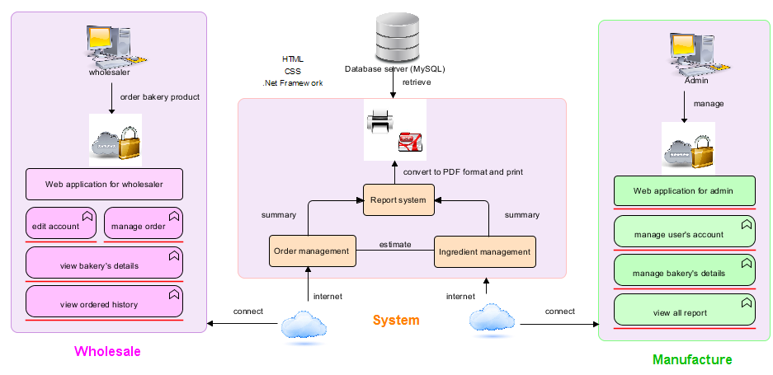

Figure 4.4.1: Web-based Ordering & Ingredient Estimation for Bakery Manufacturer

Figure 4.4.1: Shows the overview of the Web-based Ordering & Ingredient Estimating for Manufacturer. The system uses internet to connect with web application. The system provides order management system to receive orders from wholesale to estimating ingredient usage with ingredient management system and summary information into report system. Every process, summary information of the report may help the manufacturer can know the amount of ordering and ingredients usage in each day. It will store all management information to the database system (MySQL) and display summary information to the manufacturing side. Web-based Ordering System & Ingredient Estimating for Bakery Manufacturer consisted of two user’s sides. The first side supported automatically to wholesaler ordering online and also can manage their order. Another side has admin to control system and manage wholesale ordering information. The admin and the wholesaler can view their history of their own information and print graph record as a PDF form.

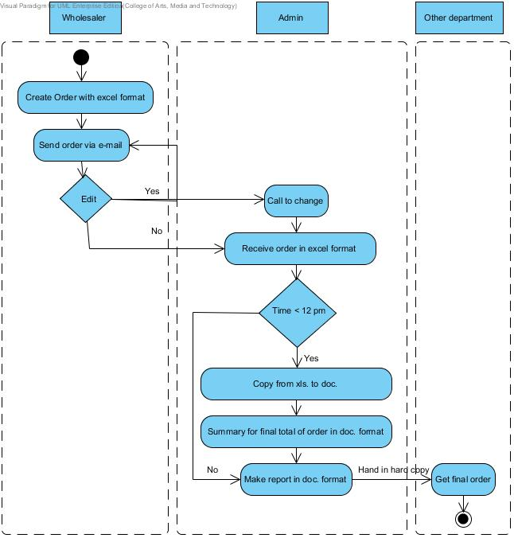

Edit

Figure 4.4.2: Flow chart of original workflow

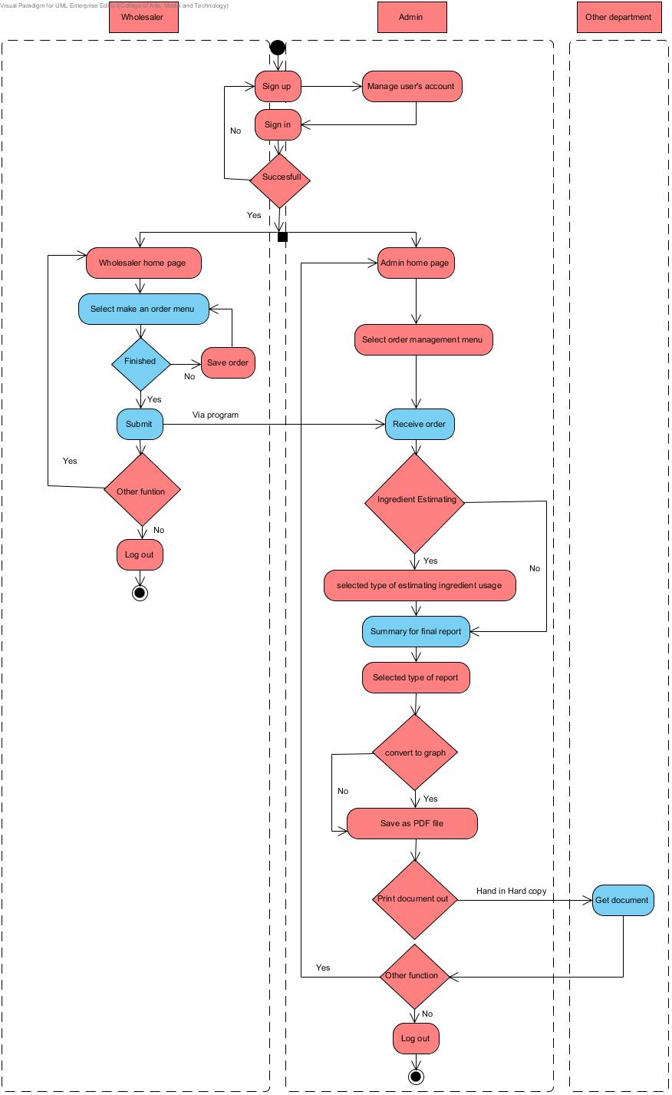

Figure 4.4.3: Flow chart of Web-based Ordering & Ingredient Estimating for Bakery Manufacturer

## Deliverables and Limits

### Deliverables

**4.5.1.1 Progress Report I**

* **Feature#1:** Member Management System

- Wholesaler and admin can login to the system.

- Wholesaler and admin can log out from the system.

- Wholesaler and admin can edit their profile.

- Wholesaler and admin can view their profile.

- Admin can create accounts of users.

- Admin can delete accounts of users.

- Admin can edit accounts of users.

- Admin can search user’s account by user ID and name.

- Admin can specify user’s type within the system.

- System can identify online status of a user.

- System can store register information into the database.

- System can receive input from the database.

- System can send user verification status to member management system.

- System can send verification status.

* **Feature#2:** Order Management System

- Wholesaler and admin can search bakery details by bakery’s name, type and price.

- Wholesaler can make an order of bakery.

- Wholesaler can repeat the ordered of bakery from their history.

- Wholesaler can save unfinished order list of bakery product.

- Wholesaler can edit their submitted order.

- Wholesaler can receive notification successful ordering by alert message on the screen.

- Admin can manage bakery’s details.

- System can receive input bakery order from a wholesaler to admin.

- System can send input bakery order to involve system.

- System can sort manufacturing date from order information.

- System can calculate the total price of bakery ordered from purchase order.

- System can calculate the discount from the total price in bakery ordered.

- System can calculate the summary bakery ordered in each type.

- System can notification when receive ordering information.

**4.5.1.2 Progress Report II**

* **Feature#3:** Ingredient management System
* Admin can manage details of bakery by provide the bakery’s name, ingredient and bakery’s quantity.
* Admin can manage ingredient type information.
* System can receive input bakery order of each day.
* System can calculate the actual number of bakery after the finished.
* System can calculate ingredient will be used in manufacturing.
* System can calculate ingredient will be used in each type.
* System can calculate quantity goal in each bakery’s type.
* System can send input ingredient usage to summary report system.

**4.5.1.3 Progress Report III**

* **Feature#4:** Summary Report System
* Wholesaler can view their order history by day, month and year.
* Admin can view wholesaler’s history by day, month and year.
* Admin can view summary wholesale order by day, month and year.
* Admin can search wholesaler’s history by name and ID.
* Admin can make wholesalers order’s report.
* Admin can make bakery preparation’s report.
* Admin can make real production’s report.
* Admin can make ingredient usage’s report.
* Admin can make bakery quantity assurance’s report.
* All report can convert to be a graph as a PDF format.
* Wholesaler and admin can print their report.
* System can receive input information from involve system to summary report system.
* System can represent a history from database.

**4.5.1.4 Software Document**

* Project Proposal
* Project Plan
* Software Requirement Specification
* Software Design Document
* Use Case
* Use Case Description
* Class Diagram
* Sequence Diagram
* Activity Diagram
* Testing Document
* Test plan
* Unit Test Document
* System Test Document
* Test Report
* Unit Test Document
* Integration Test Document
* Traceability Record
* Software Quality Assurance
* Progress Status Report
* Self-Assessment Report

### Limits

- The application required Internet connection to execute.

- This application supports only Phungnoi bakery manufacturer as a sample for developing and testing the system.

- This application cannot support stock and billing management system.

- This application cannot integrate directly with existing software.

- This application require web browser.

- This application require database server.

**4.6 Future work**

* These systems can support another functions such as stock management system and billing management system.
* This system can be used in any manufacturer.
* This system can use other technologies to provide more convenient service.

## Schedule & Milestones

According from Figure 4.7.1 to Figure 4.7.5 was show the schedule and milestones of Web Base Ordering & Manufacturing Management System. During period of time, there are work terminologies. And the description is shown below that:

**Schedule Plan:**

|  |  |  |
| --- | --- | --- |
| **Progress** | **Duration** | **Task** |
| **Proposal** | **Start:** 07 February 2014  **End:** 02 April 2014 | Proposal Document |
| **Progress I** | **Start:** 06 April 2014  **End:** 05 June 2014 | **Feature#1:** Member Management  **Feature#2:** Order Management |
| **Progress II** | **Start:** 20 June 2014  **End:** 01 August 2014 | **Feature#3:** Ingredient Management |
| **Progress III** | **Start:** 07 August 2014  **End:** 19 September 2014 | **Feature#4 :** Summary Report |
| **Final Progress** | **Start:** 27 September 2014  **End:** 20 November 2014 | System and Document are complete |

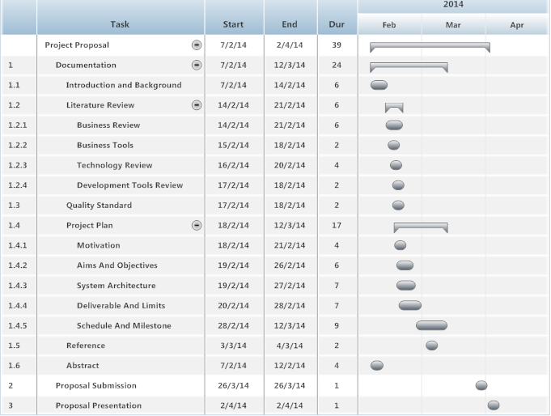

**Figure 4.7.1: Proposal Milestone MilestMilestone**

As shown in figure 4.7.1, There are the details of each task that our have done with the documentation which represent by form of start date, end date and duration.

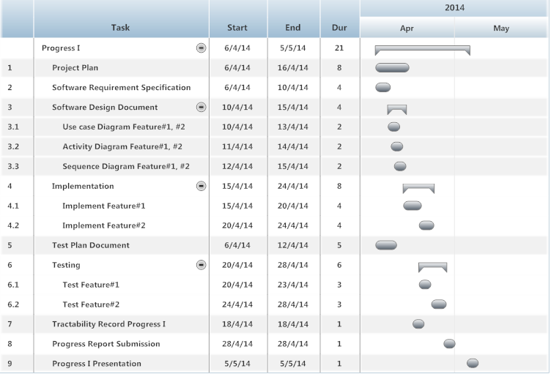

**Figure 4.7.2: Progress Report I Milestone**

As shown in figure 4.7.2, We will start develop the feature#1 and #2. In addition we will also start to do the development plan, quality plan, software requirement specification, software design, test plan and traceability record which represent by form of start date, end date and duration.

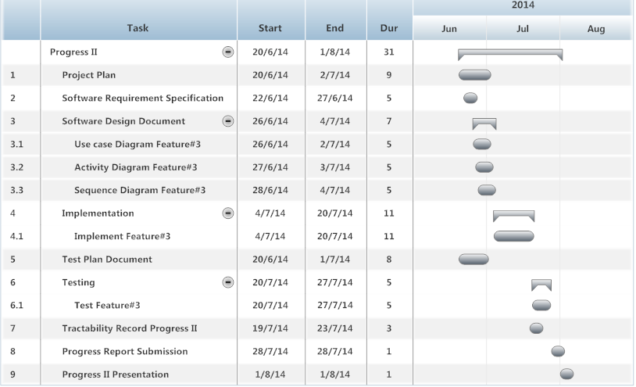

**Figure 4.7.3: Progress Report II Milestone**

As shown in figure 4.7.3, We will start develop the feature#3. In addition we will also start to do the development plan, quality plan, software requirement specification, software design, test plan and traceability record which represent by form of start date, end date and duration.

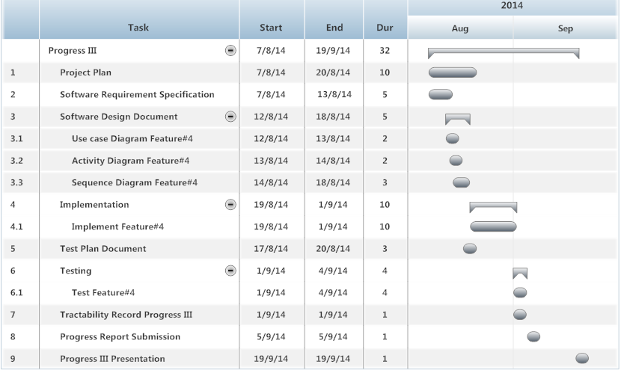

**Figure 4.7.4: Progress Report III Milestone**

As shown in figure 4.7.4, We will start develop the feature#4. In addition we will also start to do the development plan, quality plan, software requirement specification, software design, test plan and traceability record which represent by form of start date, end date and duration.

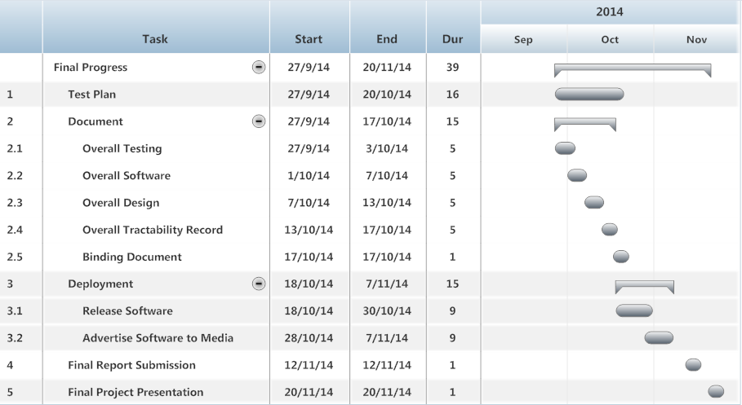

**Figure 4.7.5: Final Progress Report Milestone**

As shown in figure 4.7.5, We will start to do the development, test plan and deployment which represent by form of start date, end date and duration.

**Chapter Five | References**

[1] Wikipedia “Adobe Dreamweaver CS6” [Online]. Available from <http://en.wikipedia.org/wiki/Adobe_Dreamweaver>

[2] VSE [Online]. Available from <http://profs.etsmtl.ca/claporte/English/VSE/Deploy-Pack/Entry>

[3] Wikipedia “Project Management Process” [Online]. Available from <http://en.wikipedia.org/wiki/Project_Management_Professional>

[4] Software Implementation Process [Online]. Available from <http://profs.etsmtl.ca/claporte/English/VSE/Deploy-Pack/Entry%20Profile-DP-Software>

[5] Wikipedia “HTML” [Online]. Available from <http://en.wikipedia.org/wiki/HTML>

[6] Absolute |Solutions| [Online]. Available from <https://www.absolute.co.th/index.html>

[7] Bakery land website [Online]. Available from <http://www.bakeryland.co.th/>

[8] PRIMS [Online]. Available from <http://www.foodsafetyconnect.com/Food-Safety—Quality-Management-1069/PRIMS--Production-Recipe-Ingredient-Management-Software-328/> and <http://matrixcontrols.net/pdf/PRIMS-ROI-Advantage-Summary.pdf>

[9] Kapilbulsara “Netbeans” [Online]. Available from <http://www.kapilbulsara.com/tag/netbeans/>

[10] Software Picks Network “Netbeans” [Online]. Available from <http://www.softpicks.com/software/Development/Miscellaneous/NetBeans-IDE-180921.htm>

[11] Wikipedia “Spring Framework” [Online]. Available from <http://en.wikipedia.org/wiki/Spring_Framework>

[12] Sedona “Spring Framework” [Online]. Available from <http://blog.sedona.fr/>

[13] Wikipedia “Cascading Style Sheets” [Online]. Available from <http://en.wikipedia.org/wiki/Cascading_Style_Sheets>

[14] Microsoft “CSS3 Animations” [Online]. Available from <http://blogs.microsoft.co.il/gilf/2011/12/14/css3-animations/>

[15] Oracle “MySQL Workbench” [Online]. Available from [http://www.oracle.com/technetwork/issue-archive /book-beat-archive-1878886.html](http://www.oracle.com/technetwork/issue-archive%20/book-beat-archive-1878886.html)

[16] MySQL Workbench [Online]. Available from <http://osx.wdfiles.com/local--files/icon:mysqlworkbench/MySQLWorkbench.png>